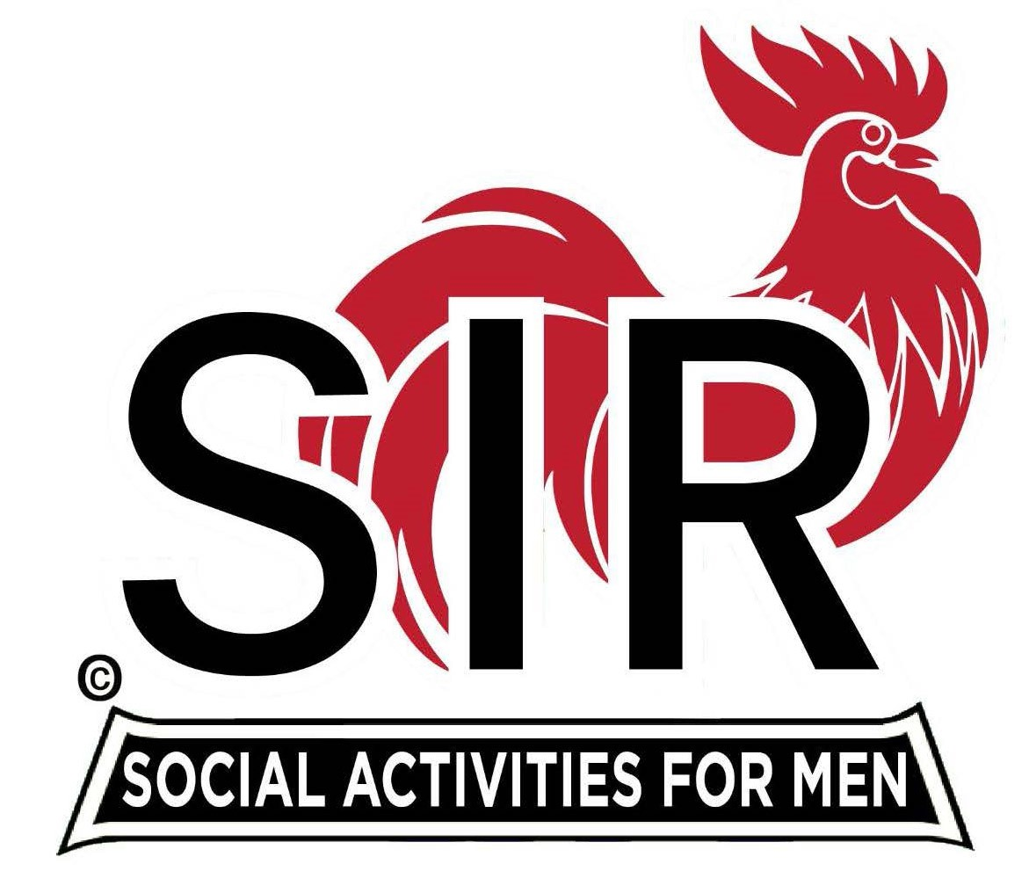

**Las Trampas Branch 116**

**BEC Meeting Agenda**

**November 18, 2024, 9:15 AM at Boundary Oak**

***The Mission of SIR is to enhance the lives of our members through fun activities, events and luncheons while making friends for life.***

**9:15 am Call to order; Secretary, Paul Ramacciotti – Confirm quorum and**

**Approval of October 21, 2024 BEC meeting minutes**

**9:20 am Standing Reports**

* **Treasurer – Charlie Guthrie** 
  + **Report**
  + **2025 Dues**
* **Luncheon Count – Charlie Guthrie**
* **Big SIR Report –**
  + **Cost of lunches 2025 - $37**
  + **Coordinate with other branches**
  + **Honor our veterans**
  + **Branch Advisory Council – Carlos Xavier**
* **Membership – Phil Goff**
  + **New member: Eric McNamara**
* **RAMP Department Head Reports:**
* **Recruitment – Don Schroeder**
  + **New members:**
* **Activity Coordinator – Mike Ward**
* **Member Relations - Sam Beret**
* **Publicity – Allan Farbman**
  + **Plans for 2025**
  + **Budget**

**9:45 am Little SIR Updates – Paul Russell**

* **Speaker Info – Lawrence Striley**
* **Birthday Boys – November**

**9:50 am Updates & New Business**

* **Recruiting Committee – Jeff Johnson**
* **New members – Alan Pope**
* **Greeters – Alan Pope**

**10:15 am Adjourn: Lunch Preparations**